Plate tectonic theory:

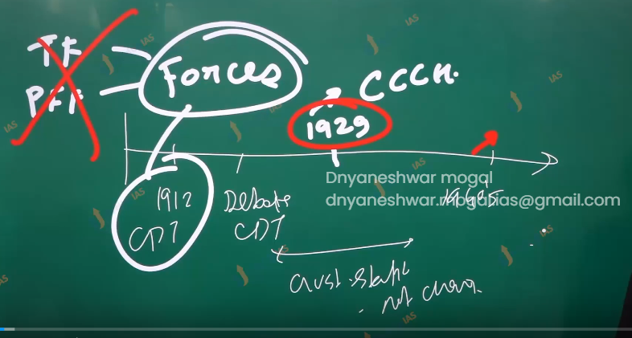

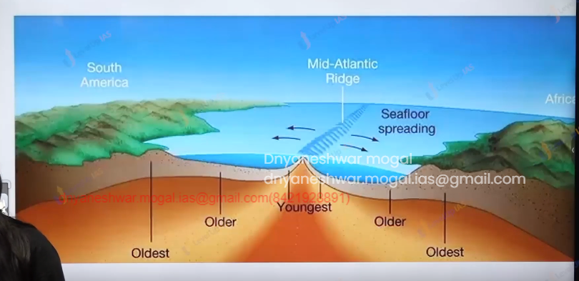

Development post continental theory till plate tectonic theory

World war and the renewed interest in ocean studies. The Idea of ocean floor mapping began in the 1930.

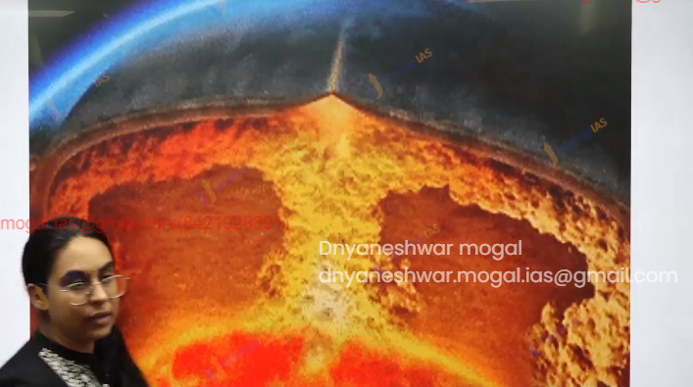

conventional current hypothesis.1929 Author Humus’s.

seafloor spreading 1960 by harry Hess.

**conventional current hypothesis:**

1. according to author humans the interior the earth is not entirely solid inside the mantle there are few places which are molten rock . they rocks circulate as part of vertical cell shell.

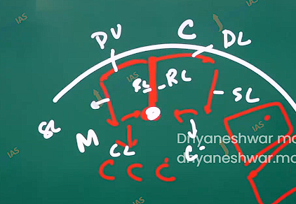

Each flow called limb

1. Rising limb
2. Diverging
3. Descending/ sinking
4. Converging.

seafloor spreading hypothesis

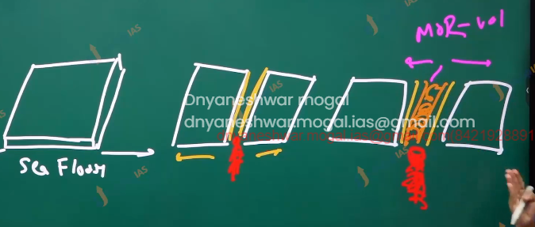

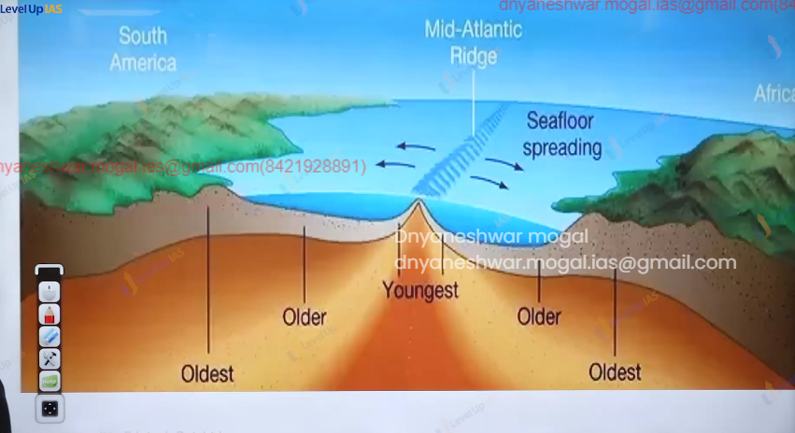

it is given by the geologist harry Hess.

According to seafloor hypothesis ocean floor getting stretch and it expanding because of this it breaking apart due to breaking, there is volcanisms the cooling of volcanic lava leads creation of new ocean floor which basaltic in the nature.

The new ocean floor gets created along the crack. The ocean floor has mid oceanic ridges in between which can experience continuous volcanisms.

Away from the ridges on either side the age of rocks is getting progressively older.

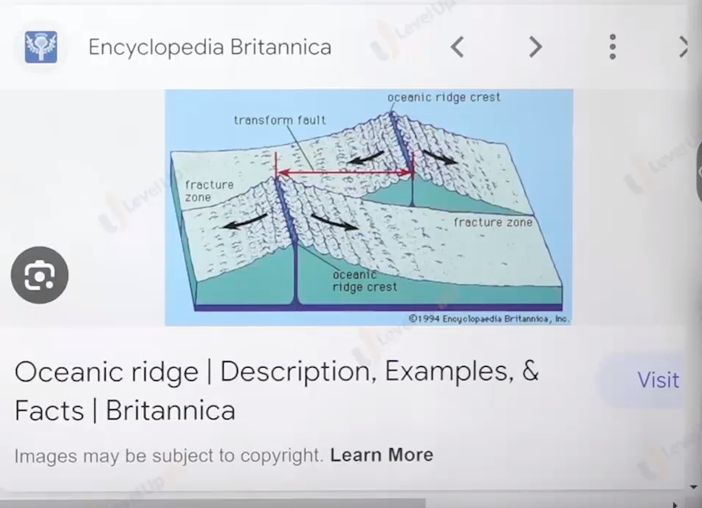

Relating convectional current cells with sea floor spreading:

1. Harry has related conventional current hypothesis and sea floor spreading. According to harry Hess the location of raising and diverging conventual current limb pull the ocean apart. Which splits and breaks thus there are basaltic accumulation that creates long linear change of basaltic mountain.
2. The continuous accumulation will raise the ocean floor these are known as mid oceanic ridges. mid oceanic ridges are long linear chain of mountain. Approx. 7000 km ex mid – Atlantic ridge.
3. The ocean floor and the mid oceanic ridge had the youngest rock due to continuous volcanic accumulation away from the amour the rocks get progressively older . far away from the amour at the location of sinking conventional cell, limb. the ocean floor may be subducted in to the mental. At the location of ocean floor subduction there is intense compression, formation of the trench scraping of the sinking ocean floor earth quacks etc.

a 

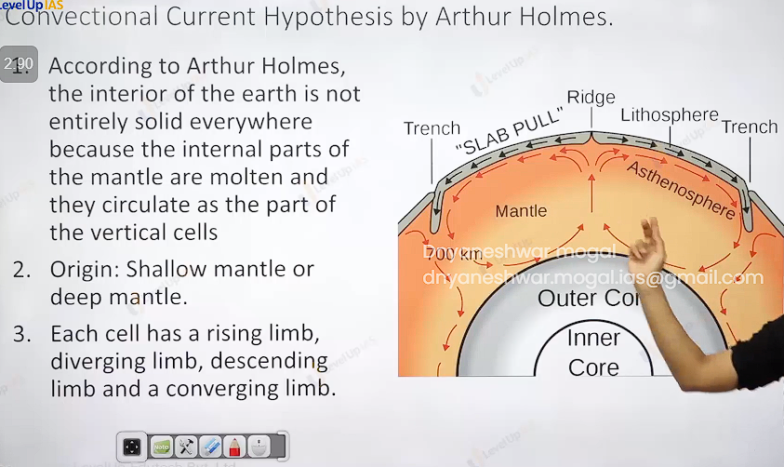

Plate tectonic theory:

Most modern theory of geomorphology. The basis of theory the non-permeants of crust, mental forces drive the lithosphere. Plate tectonic theory uses the convectional current hypothesis and sea floor spreading hypothesis.

Plate tectonic theory Postulate:

1. the first layer lithosphere. Lithospheres include oceanic crust + continental crust + upper part of upper mantel. It is 100 km thick.it cold and rigid and brittle.
2. Lithosphere floated over asthenosphere lithosphere is not continuous layer, but it is broken into lakes as lithosphere broken into small plates it interacts with the other plate this interaction of the plate forms various feature on the surfaces of earth like floalt mountain volcanos and earthquake.

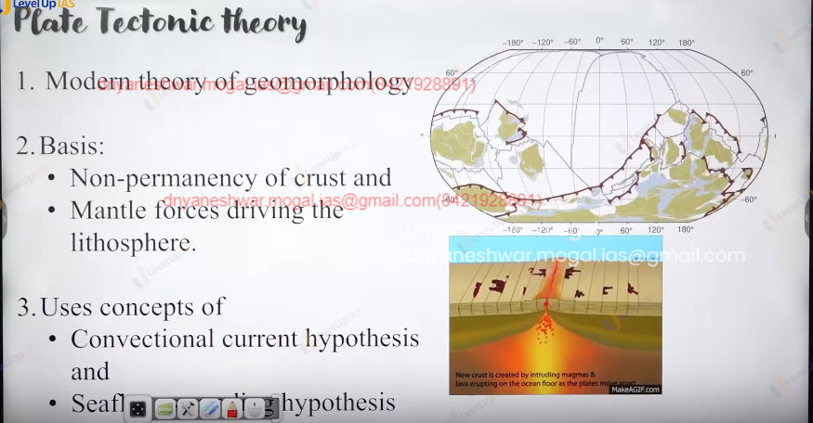

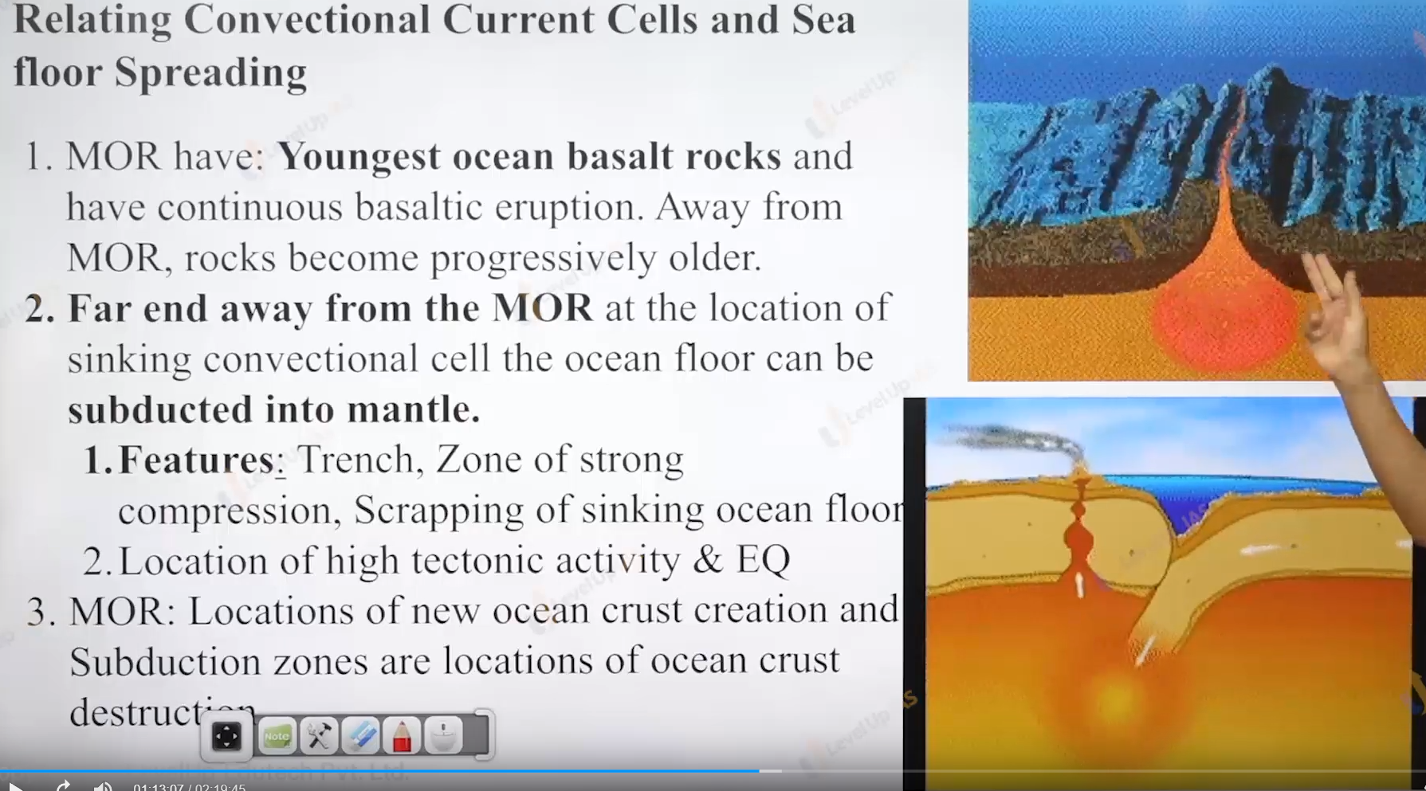

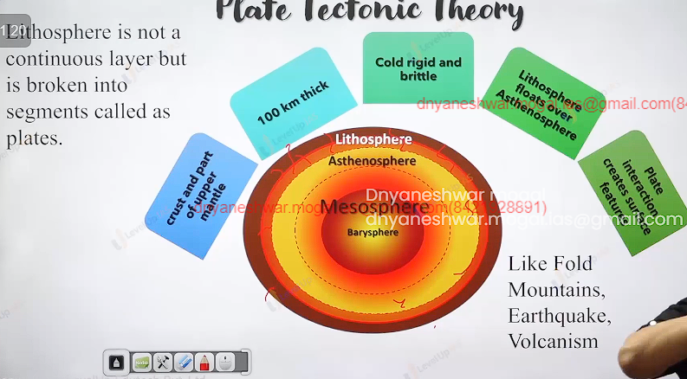

Plate interaction can be of 3 types

1. Convergence that plate can collide.
2. Divergence that plate can move away.
3. Transform that plate are flipping from one another.
4. 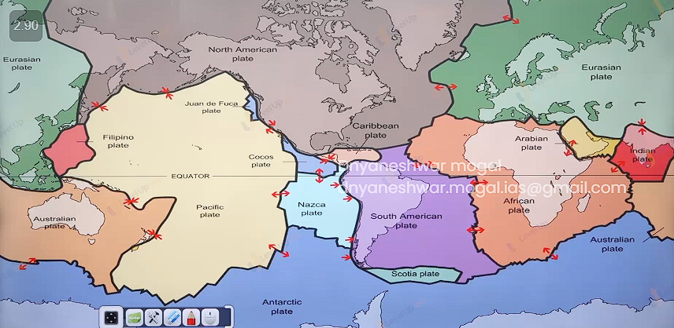

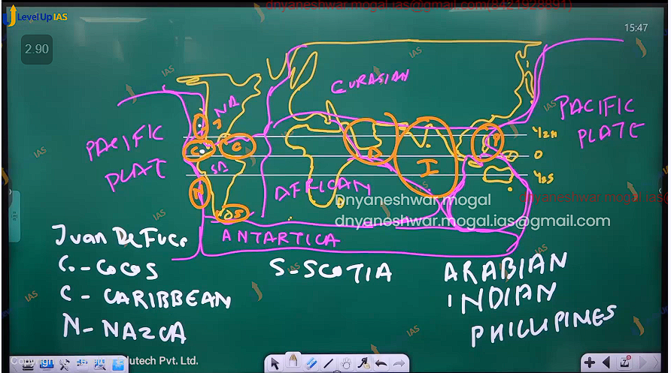

The plate can be partly oceanic and partly continental for it can be majorly oceanic for example pacific plate. And it can be majorly continental ex. Eurasian plate.

Divergent plate boundary (also known as constructive plates boundary )

It develops at the location of rising and diverging limb sit can be form below the ocean and continent the sea floor spreading is special case where divergence below the oceanic crust.

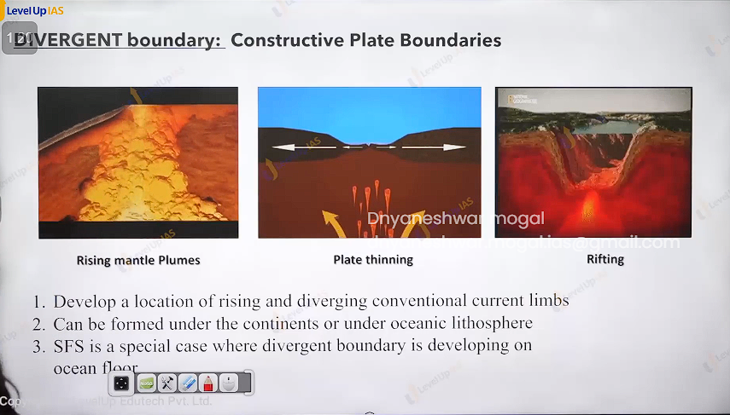

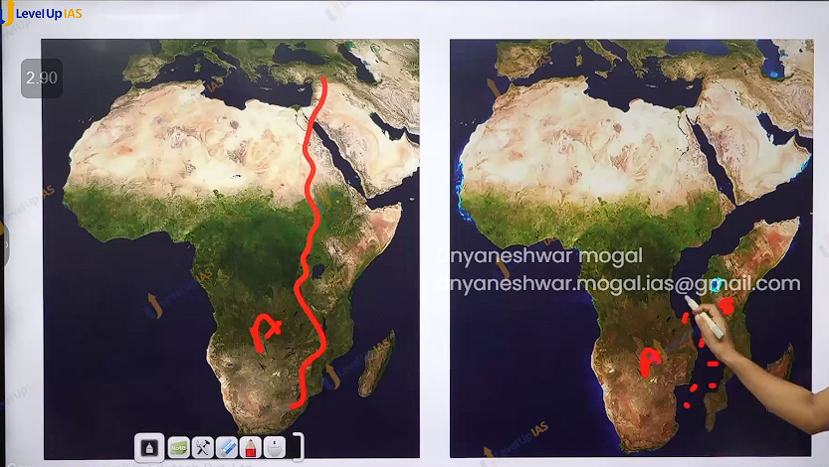

1. The oceanic crust being thin can be easily puncher to form the new ocean floor
2. Diverging boundary below the continent it undergoes following sequence
   1. the stage of continent
   2. stage of domal upliftment
   3. stage of continental thinning
   4. stage of nascent ocean
   5. stage proper ocean.

Stage of continent: over the time shape of continent gets distorted

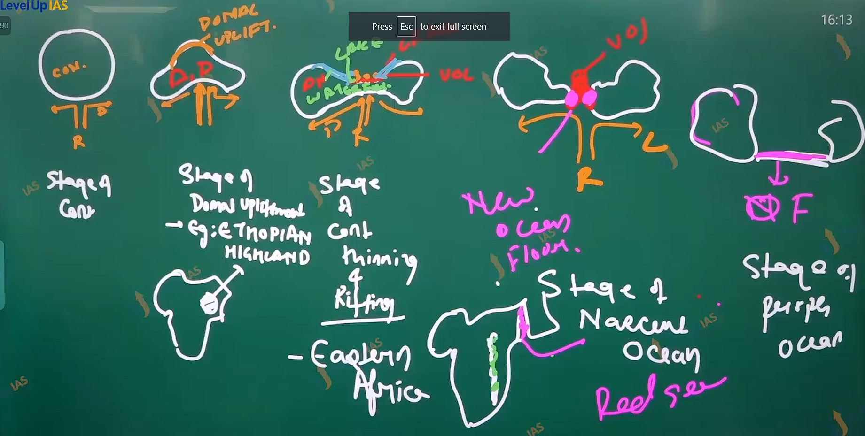

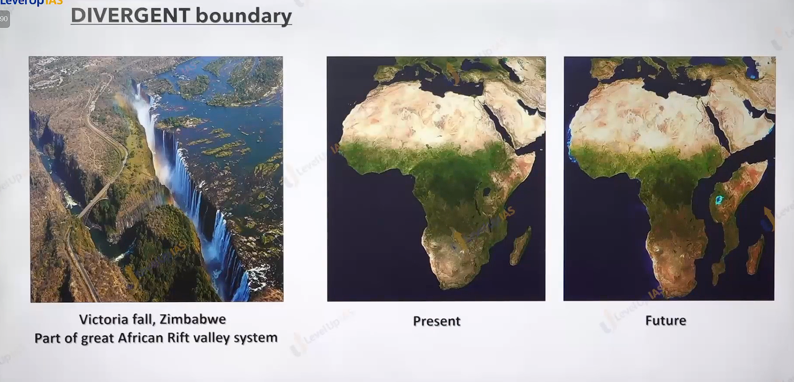

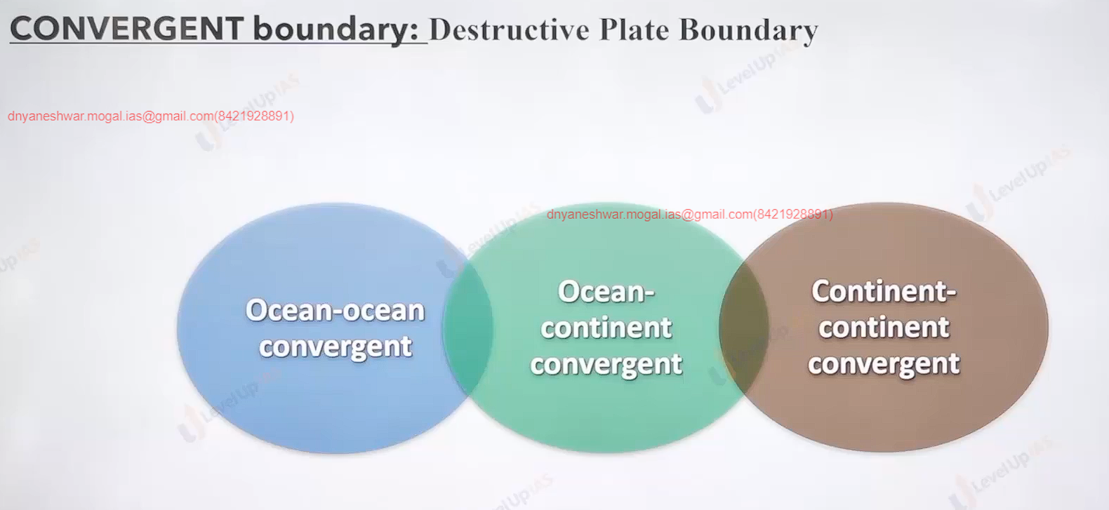

Converging plate boundary (destructive plate boundary) it is located at conventual current limb converge and decedent.

there can be 3 possibilities

1. ocean-ocean converged
2. ocean continent convergent
3. continent – continent convergent.

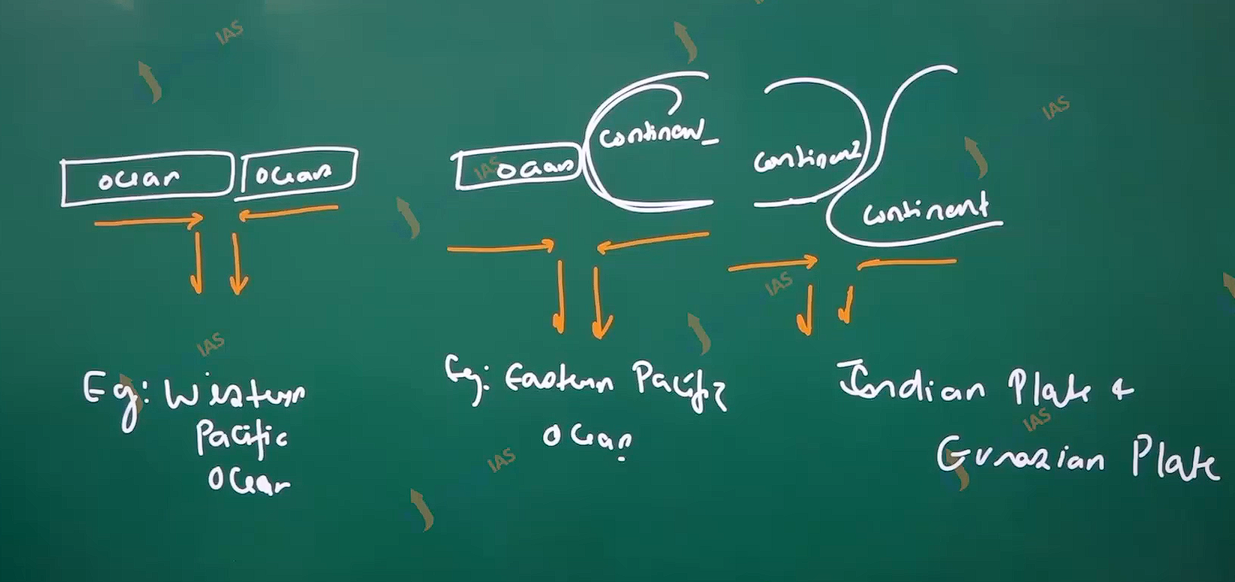

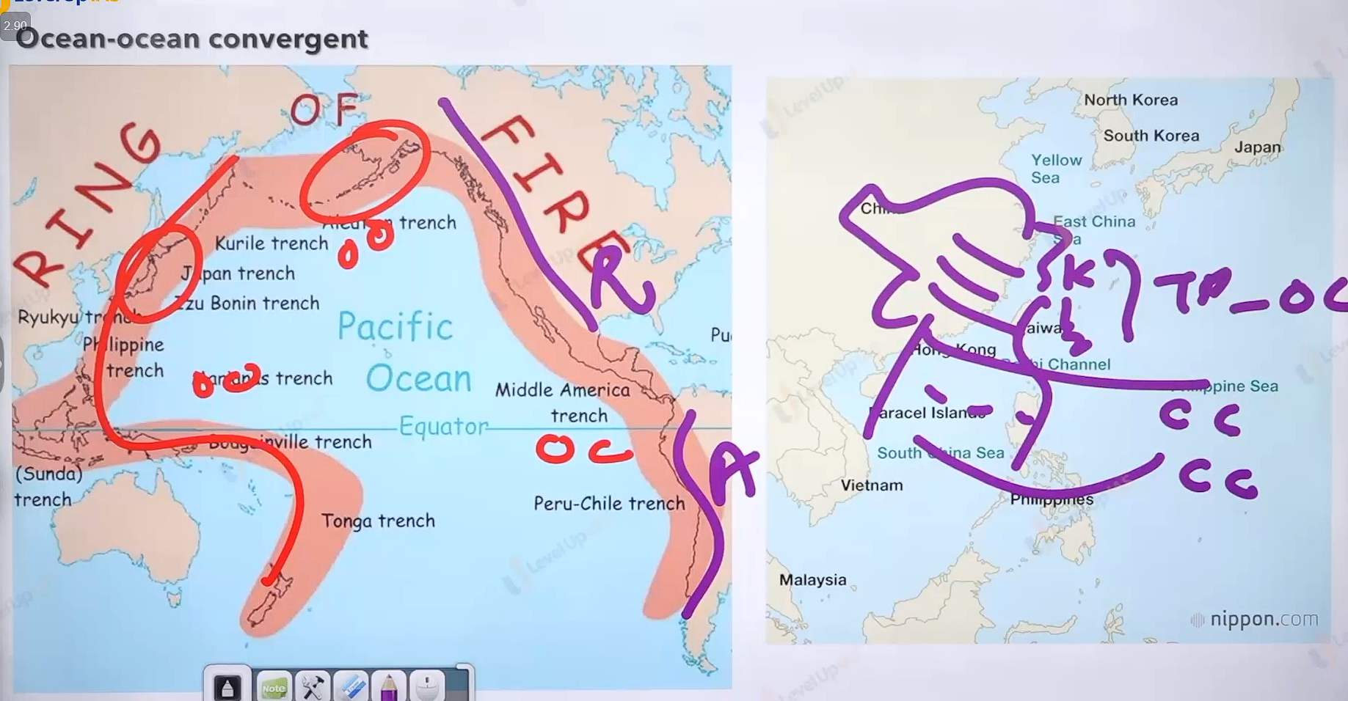

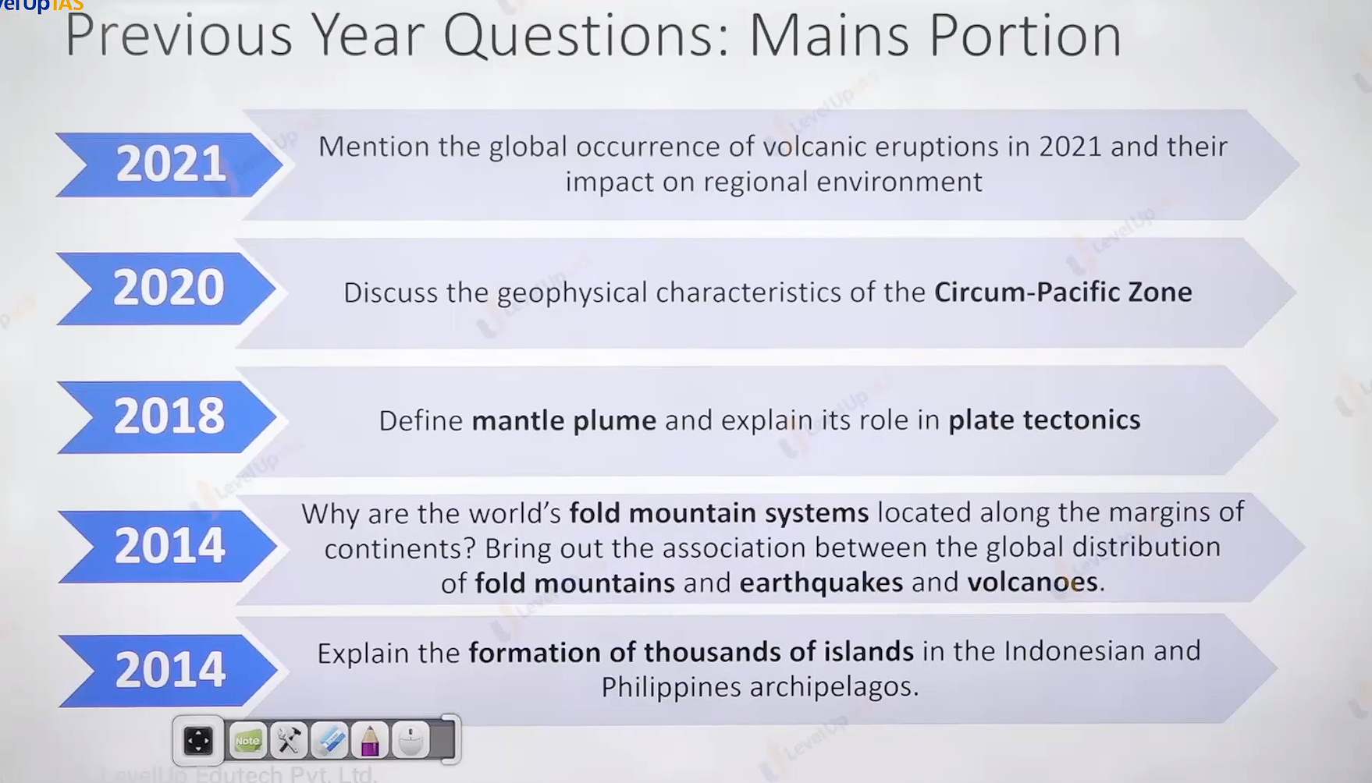

Ocean-ocean conversion:

1. depends of the relative strength’s conventional current limb, weight of ocean slab one of ocean floor will be drag and pull inside the mantle this called subduction. Linked to the process of ocean-ocean collision there are following features.
2. Trench formation
3. The sediments of subducting ocean slab get scraped, broken, deform, clustered on the other ocean slab. This scrape material is called ancestorism /accretionary wadge.
4. Subducting ocean slab can melt as it descends into mantle thus it can create volcanic accumulation called volcanic arc/archipelago. Example:

Aleutian island, Korean Island, Japanese island, Philippines islands, Indonesian island.

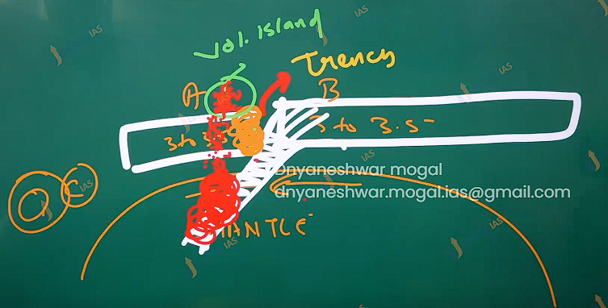

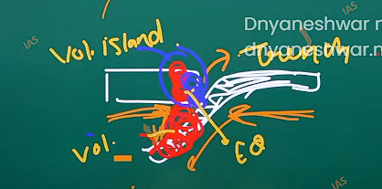

Ocean-continental conversion:

1. Ocean lithosphere is now facing the continental lithosphere.
2. This happens when ocean slab is completely subducted in ocean-ocean collision.
3. Ocean slab is dancer in continental slab therefore it will get subducted Under the continent (continental is never subducted as it lighter buoyant in nature).

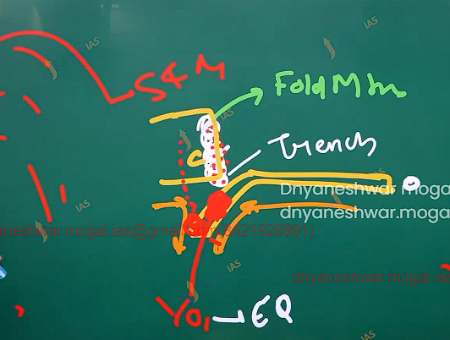

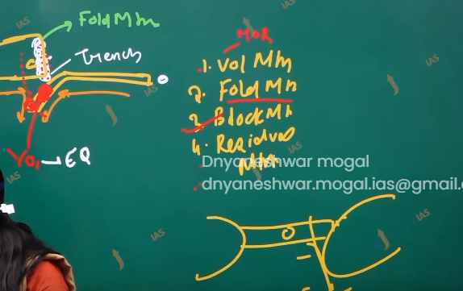

Type of mountain:

1. Volcanic mountains: -formed by mid oceanic ridge.
2. Fold mountain: =- formed by the convergent boundary. Rocks are sedimentary rocks and metamorphic rocks of marine origin.
3. Block mountain +- formed on of tectonic plate goes down. Ex western ghat.
4. Residue mountain: all mountains that are not volcanic, fold , block after long time all mountains convert into residue mountain ex Aravali.

The feature associated with o-c collision

1. Trench
2. Volcanism and earthquake
3. Enormous size of accretionary prism which plasters along the continent to become fold mountain ex : indies and rookies .
4. Subducting ocean slab will melt while descending into mantle and lead to volcanism on the continent and also along fold mountain ex ojsdellsalado , Cotopaxi , saint Helens. Chimborazo.
5. O-O collision and O-C collision are features of pacific belt.

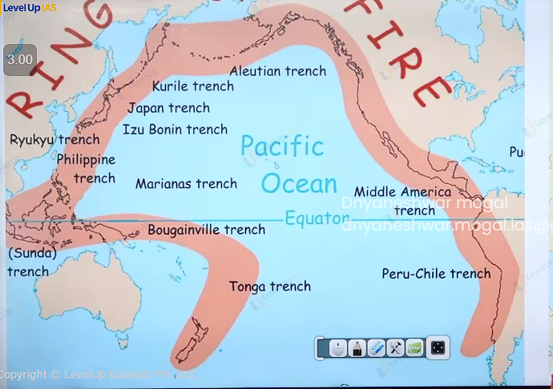

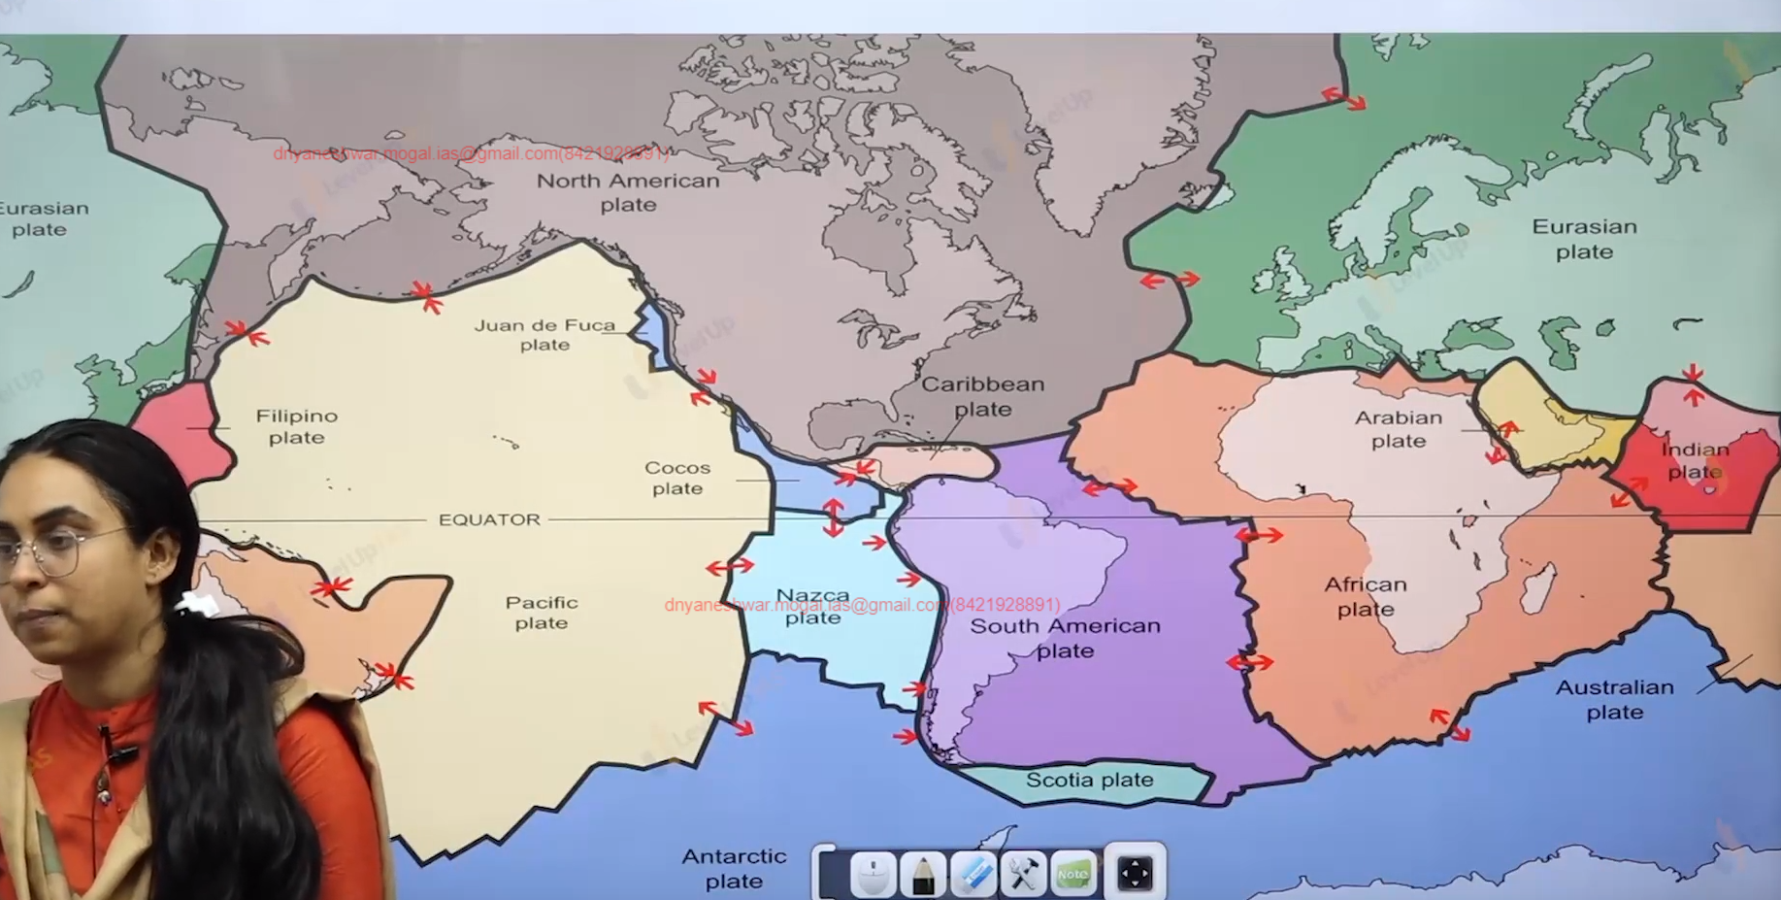

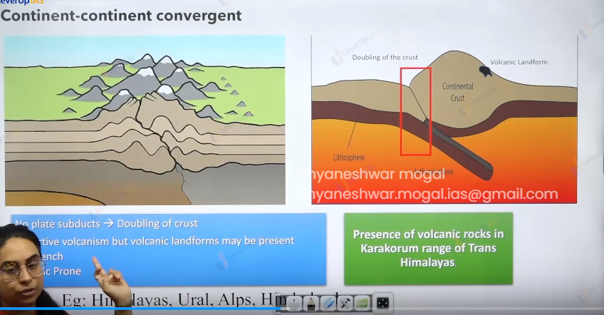

C-C collision:

1. It is considered the last stage of collision. It happened when ocean plates were completely submerged and now the continental plate face to face.
2. It has Himalayan type of fold mountains.
3. accretionary prism trap between two continental edges has enormous sediments. These sediments rise above to become fold mountains, such type of mountain has accretionary prism of both O-O & O-C collision.
4. such type of fold mountains has enormous height because of enormous sediments, dabbling of crust, strong compressive forces. Ex. Himalaya, Ural, alps, Hindukush.

Feature of C-C Collision :

1. no active volcanism
2. such collision will have volcanic rocks which are ruminant past O-C collision however they do not have active volcanism
3. there is no trench as there is no subducting ocean slab.
4. It seismic prozone example Himalayas lies in the zone of 4 and 5 as seismicity index.

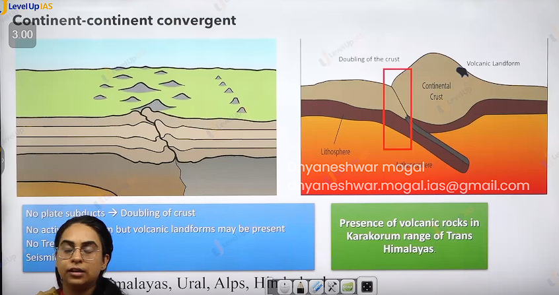

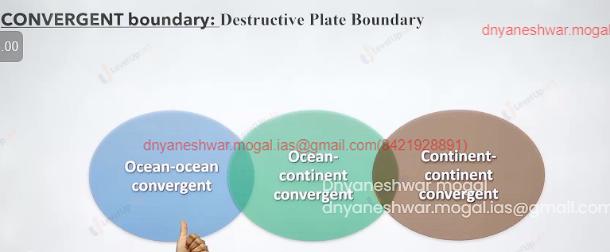

Transform boundary:

1. THE Plate slip fast one another therefore called as conservative plate boundary. There is no subducting ocean slab therefore there will be no volcanism and no trench. This place has very strong earthquake as plates are breaking and rubbing against each other. It does not have accretionary prism and does not have fold mountain
2. The plate can have some facture zones and can developed fault ex. Juan di fuca plate is sliding fast north America plate and San Andres fault.
3. 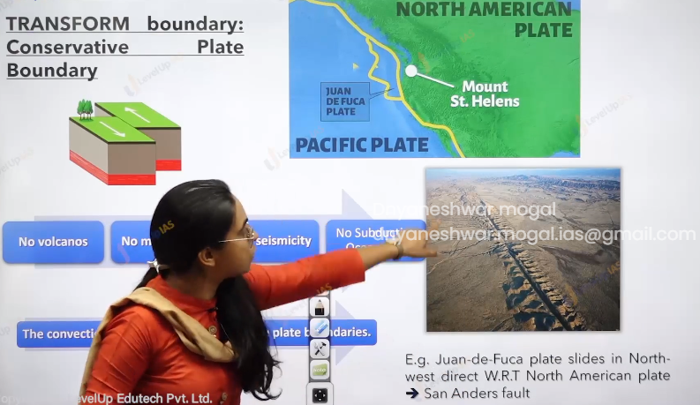
4. No volcanoes , no mountain , only seismicity , no subducting ocean slab.

Evidence of plate tectonic theory

1. All the evidence of continental drift theory zik saw fit, structural fit, paleo comatic evidence’s
2. All the evidence of seafloor spreading: mid oceanic ridge, formation vulcanism along mid ocean ridge, present of trench
3. Despite being fundamental crust and initial crust to be formed no where the oceanic crust found to be older than 200 million years. While continental rock could be dated as old as 4 billion years old it implied that oceanic crust had been destroyed and renewed. MOR represented formation of new oceanic crust while trenches represented the area of destruction of oceanic crust.

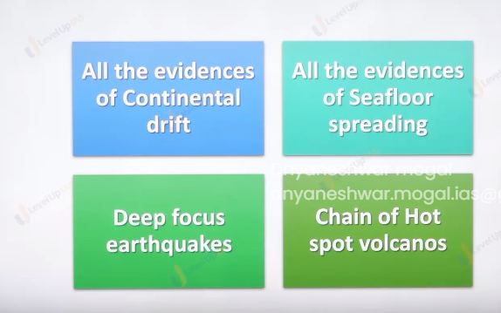

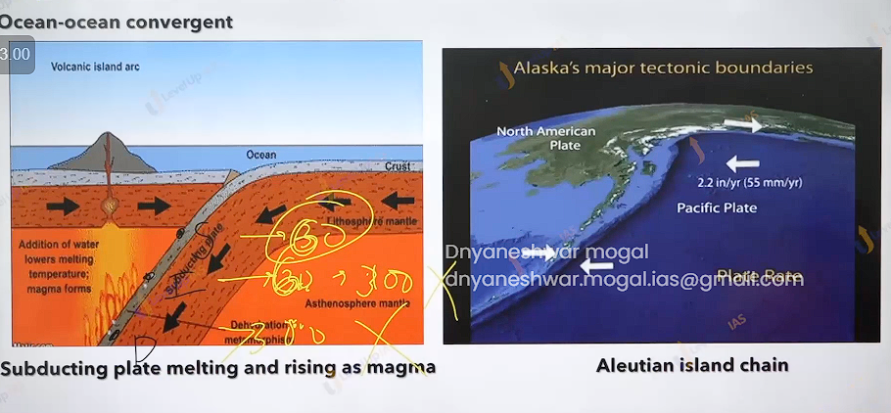

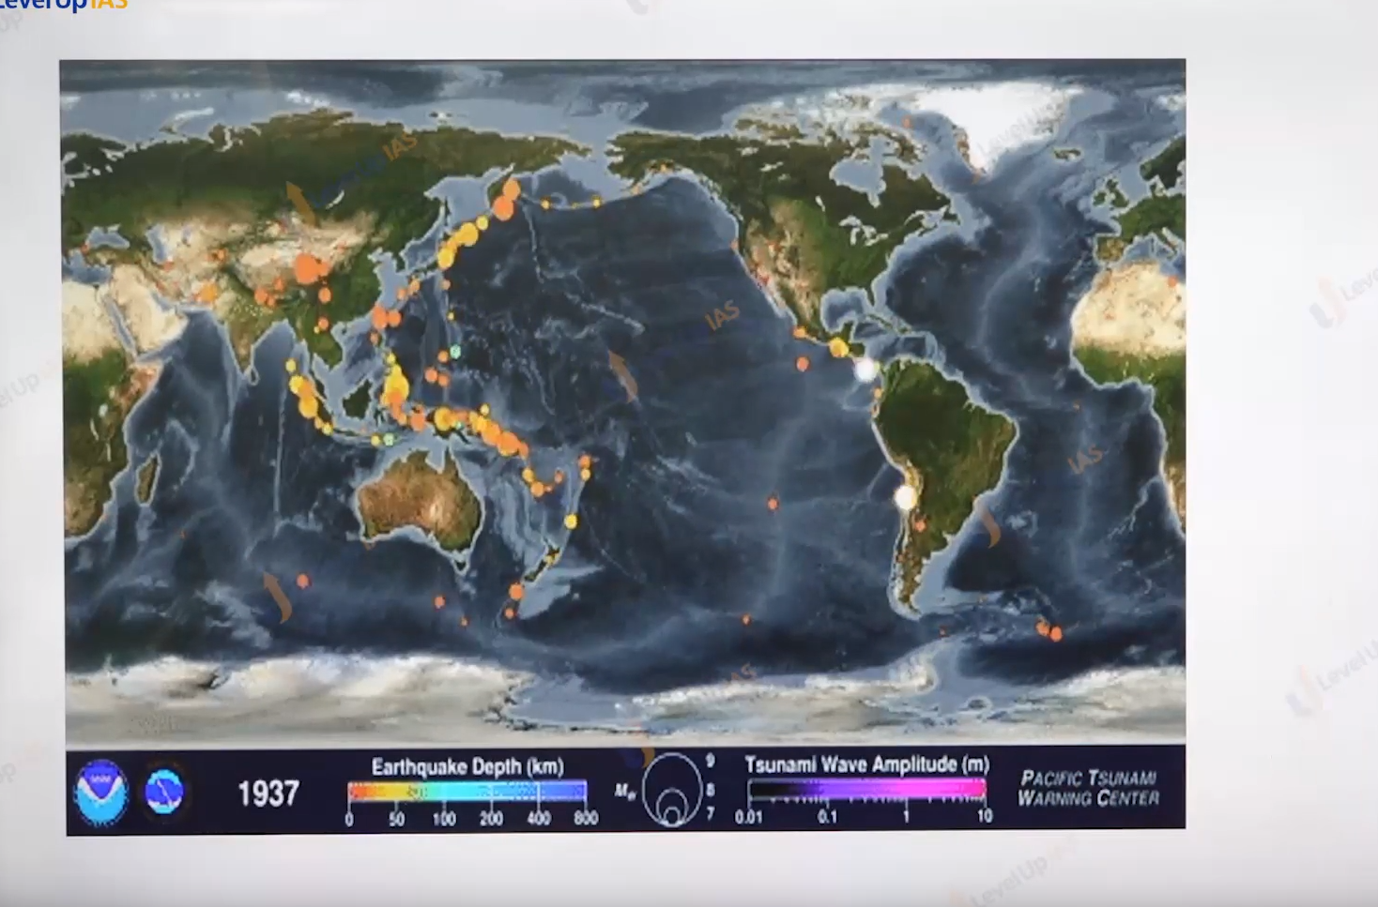

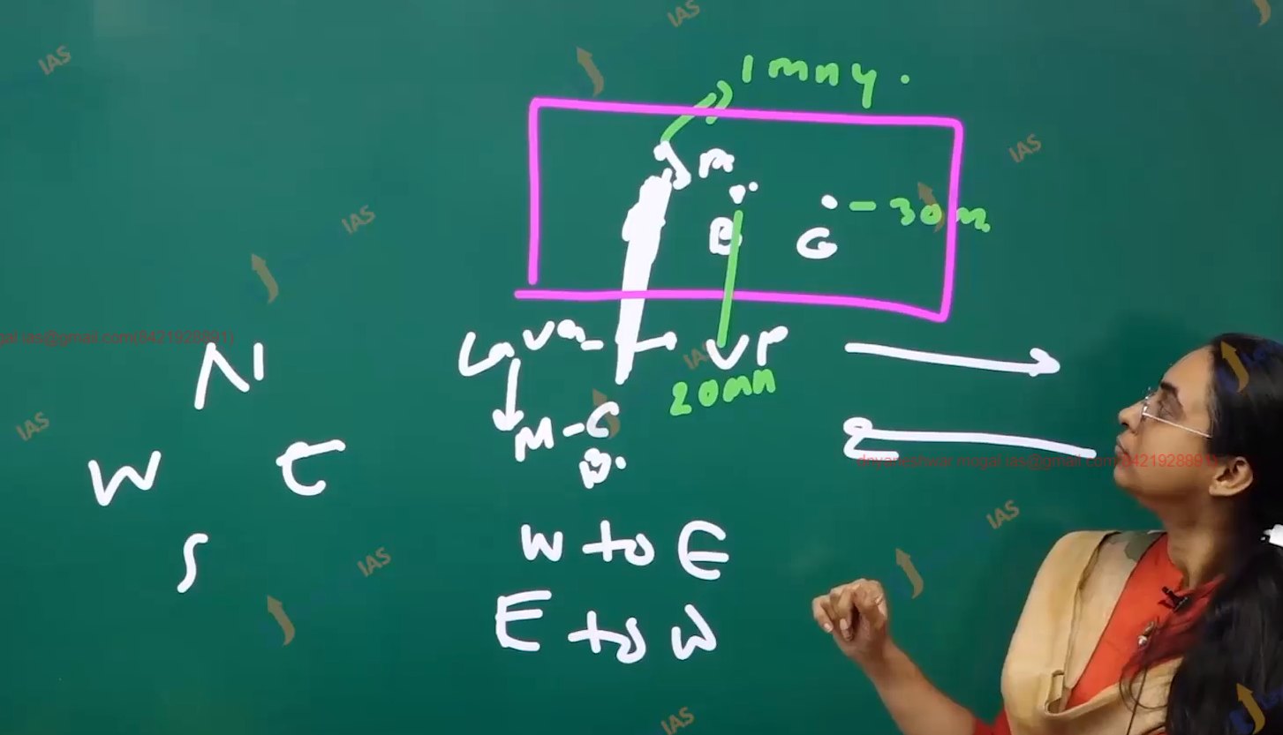

The earthquake evidence:

Earth quacks have pattern in which they are distributed. Seismic mapping under worldwide standard seismic network held plate tectonic to map the boundary of plate therefore now earthquake is location seen at the plate interaction.

Plate tectonic theory is better able to explain the shallow intermediate and deep focus earth quake (before plate tectonic theory) it easier to explain shallow focus earthquake ex continental drift theory can only explain shallow focus earth on basis of seal over sima.

1. Shallow focus earth quack 60 70 km deep,
2. Intermediate have focus earth quack as deep as 300 km
3. And deep focus earthquake below 300km ( R = 6400km).

Chain hot spot of volcano:

(Mental prove evidence)

1. A hotspot is mental plume located within the plate that is localized volcano away from the plate boundary and is not part of conventional current cell. It is also known as intra plate volcano. Such volcanisms generally have their source in the deep mantle core boundary and associated with vary vary fluoride magma modern geo-physic does not explain the origin of the hotspot but maintains that the location of hotspot is fixed. Example hotspot is French reunion hotspot, Haywain hotspot, amours hotspot gallops hotspot, while hotspots are fully understood but they are known to trace chain of volcanic island within the plate away from the boundary.
2. The chain of volcanic islands are consequence of the movement of the plate example the age and the orientation of the island in the pacific has revealed how the pacific plate has moved with Haywain island being the hotspot
3. Maladies are coral island
4. 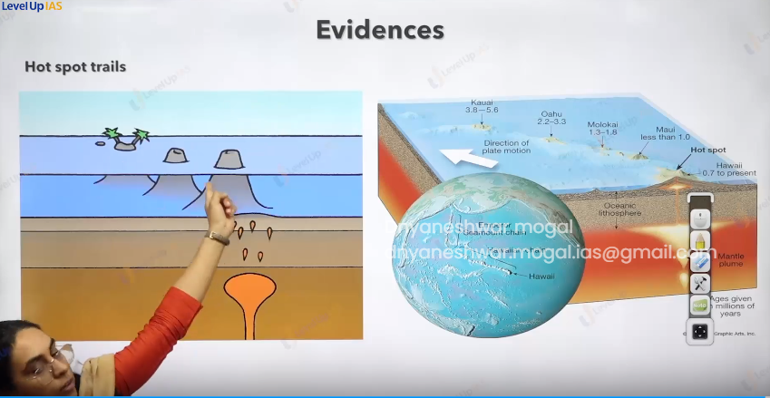

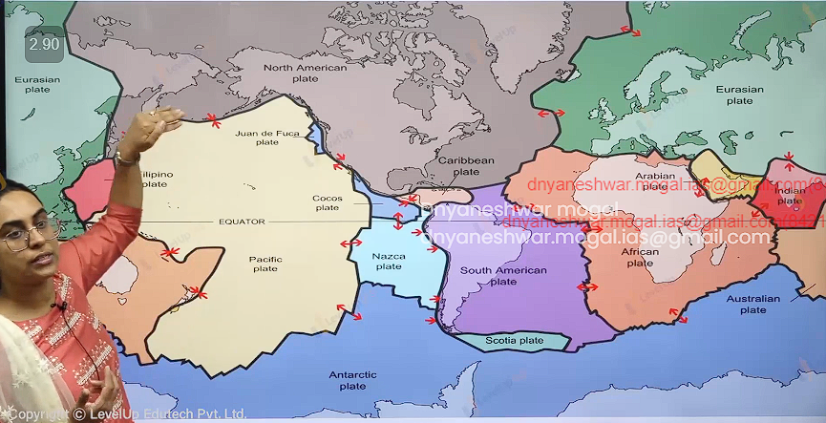

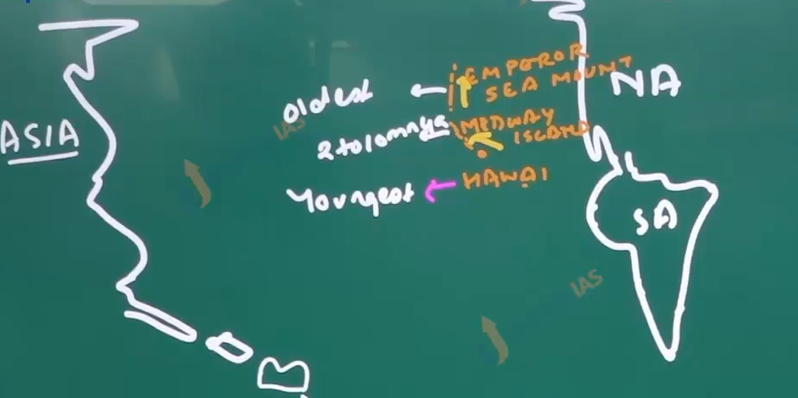

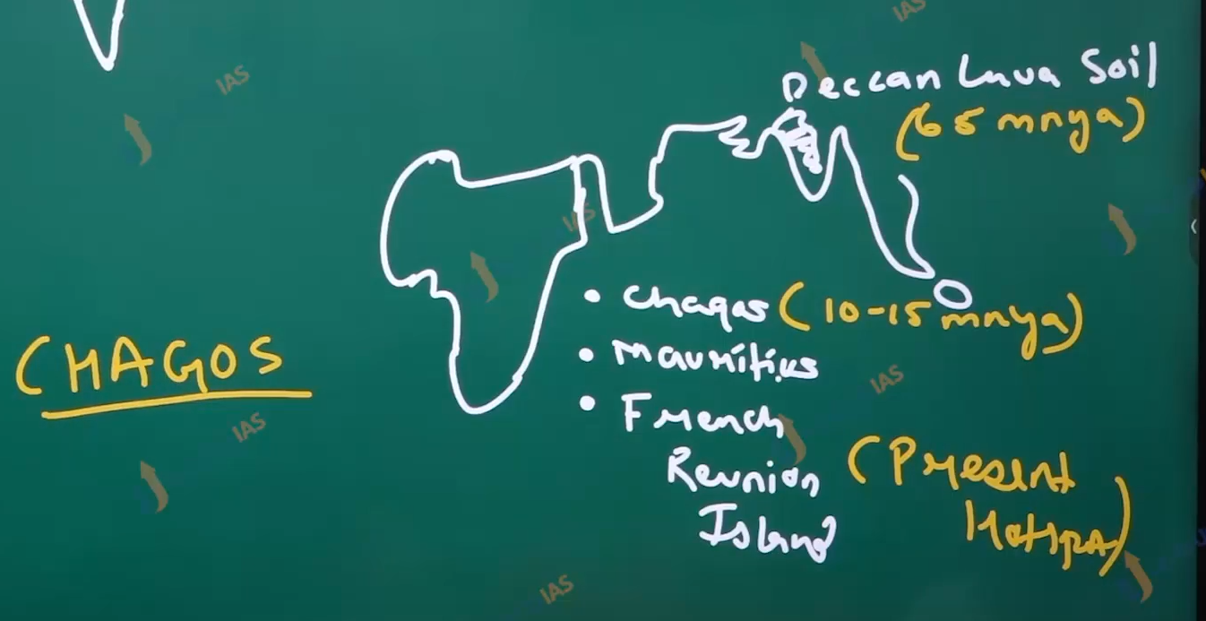

Q. discuss the natural potential of deccan lava plateau.

Forces responsible for plate motion:

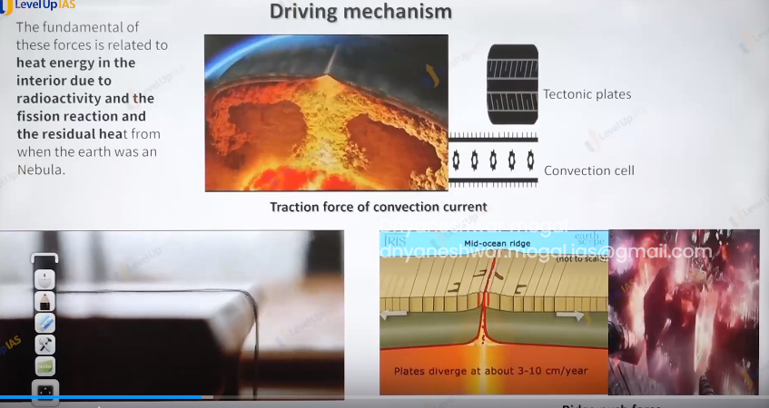

1. Convectional current:
2. Ridge push force:

Magma moving along the mid oceanic ridge forms a new lithosphere on either side of mid ocean ridge. The weight of slab feathers pushes the ocean floor.

1. Slab pull force: it is acting along the subduction zone where the subducting slab pulls the rest of slab along.
2. Gravity sliding:

the fundamental forces governing the plate movement is related to heat energy in the interior due to radio activity and dis-integrations of radioactive material element and the residual heat which is still residing in the earth from the time the earth was a nebula.

Evaluation of plate tectonic theory:

Positive:

1. most modern theory
2. It better explain the fold mountain, earthquake, volcanism.
3. It has very convincing evidence and explanations for driving mechanism

Limitation:

1. The evidence of hotspot has not been explaining properly, especially the genesis of hotspot.
2. The precise Genesis of conventional current has not been explained properly.

Earthquake: Turkey

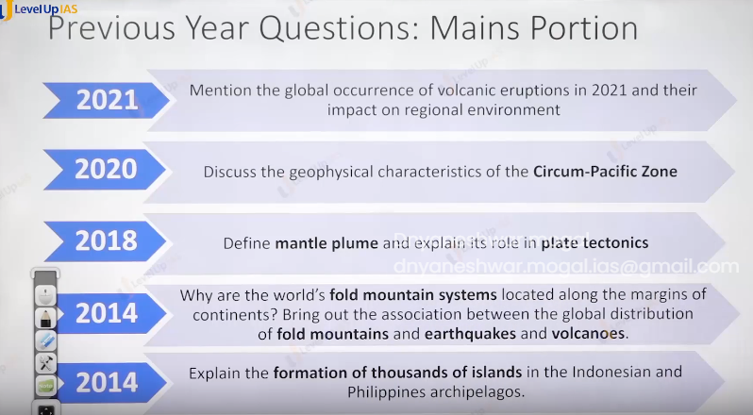

Q) describe the geophysical characteristic of cum-pacific-zone

Intro: definition, facts, current news.

Diagram:

1. Presence of tranches
2. Earthquake
3. Volcanic eruptions
4. Fold mountain.
5. Volcanic
6. Falk and fracture.

Conclusion.

Importance,develpement, seismic network ,

There are 3 types of introduction

1. Definition
2. Facts
3. Current news.

Body:

Demand the address of all the part of questions in systemic and structural way.

Conclusion:

1. Importance
2. Way forward(solution)
   1. Sgg for environment
   2. Arc for polity recommendation.
   3. Committee recommendations.
3. Future dimensions.
4. Effort taken by the government
5. Summaries when nothing works or comes in the mind.

Lavel 1 what is concept. conditional tropical cyclone

Lavel 2 compares and contrast of tropical cyclone templet cyclone

Lavel 3 how is climate changes cause increase cyclone in the Arabian sea.

Feature dimensions

Solution with arc report for authenticity.

If you don’t know then conclude what your write.

Q) plate tectonic affecting distribution of the life.

* 1. Temperature:
  2. Water
  3. Soil type
  4. Height

Above are the factors that affecting the distribution of the life.

Tell the effect of on the plate tectonic on these factors.

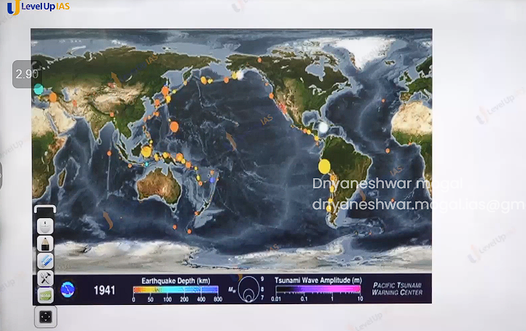

Q) define mantle plume and explain the role in the plate tectonics.

Ans : mantle plume is nothing volcanic hotspot ,

Role in plate tectonics:

1. Places the chain the volcanic island
2. Tells movement of plate and speed of tectonic plate.

Q. why are the world’s fold mountain system located along the margins of continents? bring out the association between the global distribution of fold mountain and earthquakes and volcanoes.

Q. Explain the formation of thousands of islands in the Indonesia and phippines Philippines archipelago.

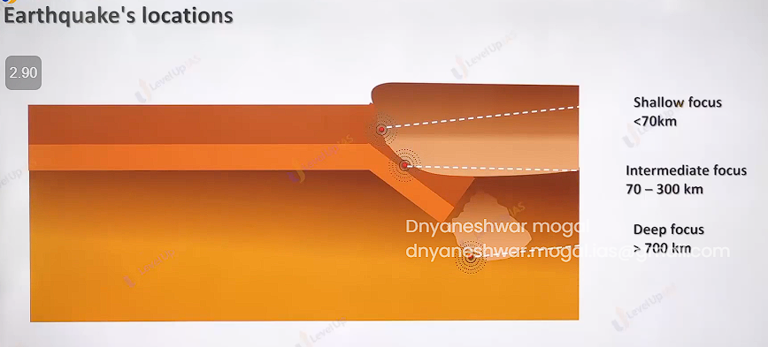

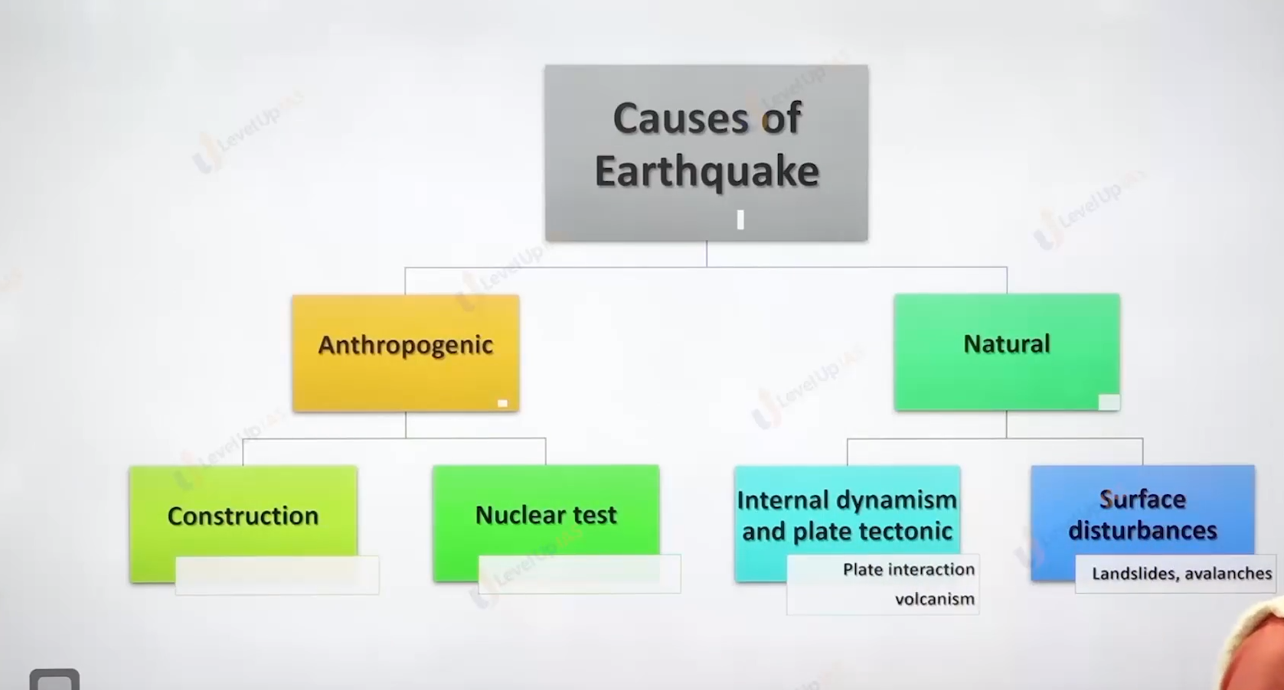

Hazards = potential threats.

Disaster = hazards * venerably / preparedness

Earthquake:

earthquake refers to vigorous shaking of earth caused by the disturbance within the earth surface.

Focus/ hypo center: It is place of origin of an earthquake inside the earth. The depth of focus varies just below the surface to as deep as 700 KM and beyond.

Classification of earthquake on the basis of focus:

1. Shallow focus <70 km
2. Intermediate focus 70 – 300 km
3. Deep focus Deep focus 700km >

Epi center: place on the surface of the earth which is just above the focus of earthquake. The epicenter records seismic wave first on the surface of the earth.

Causes of the Earthquake:

1. The earthquake causes disequilibrium which can be caused due to some nature causes or some anthropologic cause.
2. natural causes: volcanism, plate interaction, land slide and avalanches
3. anthropogenic cause: drilling, nuclear explosion, artificial resources with huge load.

Volcanism: each volcanic eruption is followed by an earthquake. The magnitude of earthquake depends on the strength of volcanic eruption ex

1. The Krakatoa volcanic eruption 1883 along the Sundae state led to release of seismic wave for nearly 6 months.
2. Nearly all the tectonic events are placed on boundary of the plate ex. Divergent plate boundary.
3. Earthquake on shallow ex: mid Atlantic ridge.

Convergent plate boundary the earthquake witnesses shallow focus intermediate focus.

And deep focus earthquake. Pacific ring of fire alpheid Himalayan belt (they witness majorly shallow focus earthquake)

Transform plate boundary: majorly shallow focus earthquake. Hotspot location can be witnessed.

Reactivation of the ancient causes: Bhuj, Latur earthquake.

Land slide and avalanches:

Humans induce causes:

1. Pumping of the ground water or drilling or mining or blasting of the rock dynamite or nuclear explosion can disturbed the equilibrium of the rock which can leads to sudden release of energy from the interior of the earth.
2. Reservoir induces seismicity: - storage of large volume water in the reservoir can create additional load on the rocks below this destroys the equilibrium causes the shaking of the earth. Ex in 1967 Konya in the Maharashtra was due to koyna reservoir construction, 1936 major earthquake was felt in USA due to huver dam in the Colorado river.

